How to connect to EC2 Instances

Connect with Systems Manager (recommended):

1. Select instance you want to connect to.
2. 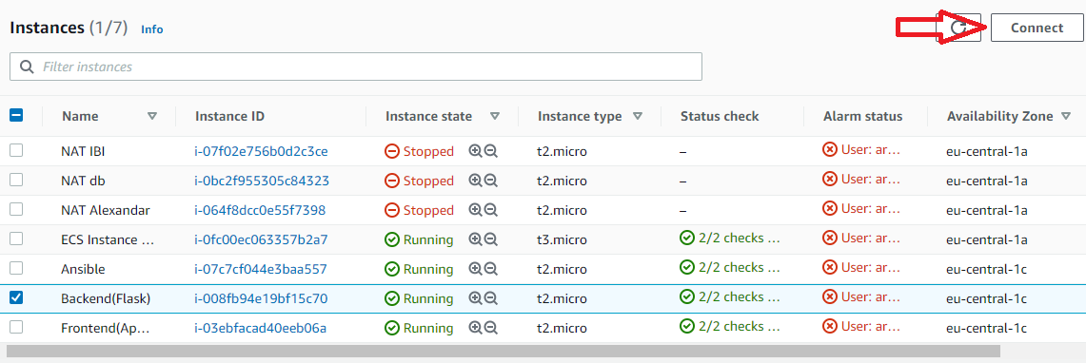Press Connect
3. 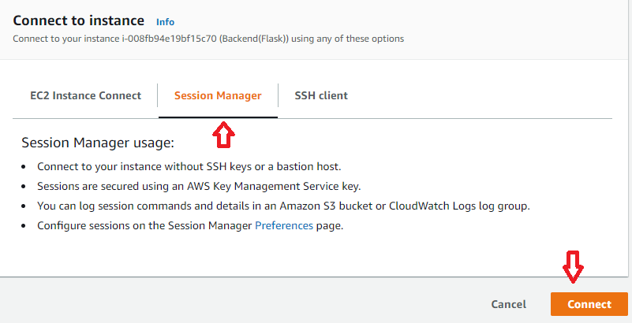Choose System Manager and Connect

Connect via SSH

1. Select Instance you want to connect to.
2. Press Connect
3. Choose SSH Client
4. Copy ssh command to connect to the EC2 Instance. (Google on how to connect via SSH)

**Note: You need to have SSH key beforehand**

**Note: If you are using Windows and cmd.exe to connect to EC2, you will need to disable inheritance and delete most of the permissions and leave only your user full control.**